Assignment 3
Truong Thi Nhu Quynh_22118573
Table of Contents

Assignment Declaration
Ensure this declaration is visible and readable on the cover page.

By including this statement, we the authors of this work, verify that: * We hold a copy of this assignment that we can produce if the original is lost or damaged. * We hereby certify that no part of this assignment/product has been copied from any other student’s work or from any other source except where due acknowledgement is made in the assignment. * No part of this assignment/product has been written/produced for us by another person except where such collaboration has been authorised by the subject lecturer/tutor concerned. * We are aware that this work may be reproduced and submitted to plagiarism detection software programs for the purpose of detecting possible plagiarism (which may retain a copy on its database for future plagiarism checking). * We hereby certify that we have read and understand what the School of Computing, Engineering and Mathematics defines as minor and substantial breaches of misconduct as outlined in the learning guide for this unit.

Note: An examiner or lecturer/tutor has the right not to mark this project report if the above declaration has not been added to the cover of the report. Note on GenAI Use: No Generative AI use is allowed for this assignment. You can use extra library you think it is useful in your assignment. Please also be reassured that the data used in this assignment is syntethic records.

Solution

First, I start with loading the libraries and datasets

Load libraries
library(tidyverse)
library(lubridate)
library(kableExtra)

Load and examine dataset
conditions <- read.csv("conditionsUG.csv")
encounters <- read.csv("encountersUG.csv")
patients <- read.csv("patientsUG.csv")
str(conditions)
## 'data.frame': 86215 obs. of 7 variables:
## $ X : int 1 2 3 4 5 6 7 8 9 10 ...
## $ START : chr "2019-02-15" "2019-10-30" "2020-03-01" "2020-03-01" ...
## $ STOP : chr "2019-08-01" "2020-01-30" "2020-03-30" "2020-03-01" ...
## $ PATIENT : chr "f0f3bc8d-ef38-49ce-a2bd-dfdda982b271" "f0f3bc8d-ef38-49ce-a2bd-dfdda982b271" "f0f3bc8d-ef38-49ce-a2bd-dfdda982b271" "f0f3bc8d-ef38-49ce-a2bd-dfdda982b271" ...
## $ ENCOUNTER : chr "d5ee30a9-362f-429e-a87a-ee38d999b0a5" "8bca6d8a-ab80-4cbf-8abb-46654235f227" "681c380b-3c84-4c55-80a6-db3d9ea12fee" "681c380b-3c84-4c55-80a6-db3d9ea12fee" ...
## $ CODE : num 6.54e+07 6.54e+07 3.87e+08 8.41e+08 8.41e+08 ...
## $ DESCRIPTION: chr "Otitis media" "Otitis media" "Fever (finding)" "Suspected COVID-19" ...
str(encounters)
## 'data.frame': 238327 obs. of 13 variables:
## $ X : int 1 2 3 4 5 6 7 8 9 10 ...
## $ Id : chr "d5ee30a9-362f-429e-a87a-ee38d999b0a5" "6a74fdef-2287-44bf-b9e7-18012376faca" "8bca6d8a-ab80-4cbf-8abb-46654235f227" "821e57ac-9304-46a9-9f9b-83daf60e9e43" ...
## $ START : chr "2019-02-16T01:02:32Z" "2019-08-02T01:02:32Z" "2019-10-31T01:02:32Z" "2020-01-31T01:02:32Z" ...
## $ STOP : chr "2019-02-16T01:17:32Z" "2019-08-02T01:32:32Z" "2019-10-31T01:17:32Z" "2020-01-31T01:17:32Z" ...
## $ PATIENT : chr "f0f3bc8d-ef38-49ce-a2bd-dfdda982b271" "f0f3bc8d-ef38-49ce-a2bd-dfdda982b271" "f0f3bc8d-ef38-49ce-a2bd-dfdda982b271" "f0f3bc8d-ef38-49ce-a2bd-dfdda982b271" ...
## $ ENCOUNTERCLASS : chr "outpatient" "wellness" "outpatient" "wellness" ...
## $ CODE : int 185345009 410620009 185345009 410620009 185345009 410620009 410620009 50849002 185345009 185345009 ...
## $ DESCRIPTION : chr "Encounter for symptom" "Well child visit (procedure)" "Encounter for symptom" "Well child visit (procedure)" ...
## $ BASE_ENCOUNTER_COST: num 129 129 129 129 129 ...
## $ TOTAL_CLAIM_COST : num 129 129 129 129 129 ...
## $ PAYER_COVERAGE : num 69.2 129.2 69.2 129.2 69.2 ...
## $ REASONCODE : num 65363002 NA 65363002 NA NA ...
## $ REASONDESCRIPTION : chr "Otitis media" "" "Otitis media" "" ...
str(patients)
## 'data.frame': 9264 obs. of 11 variables:
## $ X : int 3600 532 5907 7462 10390 7818 8381 6826 12062 4881 ...
## $ Id : chr "6aa2e953-ad8f-48cb-909b-30fb9522ebf8" "9718334c-3289-4b1c-a017-72f3df283ab3" "de9f5575-ae1c-4df5-9ef1-92a845ed99c2" "c10ee469-6182-4228-ac26-21bcf2412337" ...
## $ BIRTHDATE: chr "1988-03-17" "1951-06-13" "2006-02-06" "1912-10-28" ...
## $ DEATHDATE: chr "" "" "" "2016-11-01" ...
## $ MARITAL : chr "M" "M" "" "S" ...
## $ RACE : chr "white" "black" "white" "black" ...
## $ GENDER : chr "F" "M" "M" "F" ...
## $ CITY : chr "Rehoboth" "Boston" "Foxborough" "Springfield" ...
## $ STATE : chr "Massachusetts" "Massachusetts" "Massachusetts" "Massachusetts" ...
## $ COUNTY : chr "Bristol County" "Suffolk County" "Norfolk County" "Hampden County" ...
## $ ZIP : int NA 2113 2035 1020 2184 2184 NA 2128 NA 2119 ...

Question 1

Task explanation
This question aims to analyse how COVID-19 patients are distributed geographically (by county) and demographically (by age group). The analysis involves identifying patients diagnosed or suspected with COVID-19, then visualising their distribution using histograms (bar charts).

Analysis 1: The distribution of COVID patients across counties
#1. Filter conditions to find COVID patients (confirmed or suspected)
covid_patients_id <- conditions %>%
filter(str_detect(DESCRIPTION, regex("COVID", ignore_case = TRUE))) %>%
distinct(PATIENT) %>%
rename(Id = PATIENT)
#I extract a unique list of patient IDs whose condition description contains the word “COVID”. This step isolates the relevant subset of patients for further analysis.
# 2. Merge the list of COVID patients with the demographic dataset
covid_patients_with_county <- patients %>%
inner_join(covid_patients_id, by = "Id") %>%
select(Id, COUNTY)
#I join the filtered COVID patient IDs with the patients dataset to include county information.This helps analyse how many COVID patients are recorded per county.
# 3. Calculate patient distribution by county
county_distribution <- covid_patients_with_county %>%
count(COUNTY, name = "Patient_Count", sort = TRUE)
#I use count() to summarise the total number of patients per county. The result is sorted in descending order to identify the most affected areas.
# 4. Display county summary table
kable(county_distribution, caption = "Distribution of COVID patients across counties",
align = c("c", "c"))
Distribution of COVID patients across counties
COUNTY | Patient_Count
Middlesex County | 1595
Worcester County | 875
Suffolk County | 776
Essex County | 767
Norfolk County | 723
Bristol County | 571
Plymouth County | 487
Hampden County | 458
Barnstable County | 205
Hampshire County | 166
Berkshire County | 133
Franklin County | 70
Dukes County | 20
Nantucket County | 17
#The table clearly shows how COVID-19 cases vary by county. I use kable() for neat and professional formatting suitable for reports.
# 5. Create the histogram (bar chart) visualization for County distribution
county_plot <- county_distribution %>%
ggplot(aes(x = reorder(COUNTY, -Patient_Count), y = Patient_Count)) +
geom_bar(stat = "identity", fill = "#3399FF") +
labs(title = "COVID-19 Patient Distribution Across Counties",
x = "County",
y = "Number of COVID Patients") +
theme_minimal() +
theme(axis.text.x = element_text(angle = 45, hjust = 1, size = 8))
county_plot
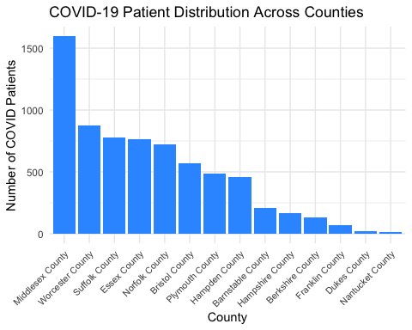
Distribution of COVID patients across counties
#A bar chart (histogram-style) visualises the concentration of COVID-19 patients by county. It highlights which geographic areas have the highest case volumes.

Interpretation
The histogram clearly illustrates that the distribution of COVID-19 patients is highly uneven (skewed) across the counties. There is a significant disparity in patient counts, with Middlesex County reporting over 1,500 cases, which is substantially higher than other large counties like Worcester and over a hundred times greater than the sparsely populated counties of Dukes and Nantucket. This stark difference is primarily attributable to variations in population size and density, as major metropolitan areas typically serve as hubs for both residence and service use, leading to higher population totals and consequently, higher absolute case counts. ## Analysis 2: the distribution of patients across age groups (e.g., 0-18,19-35, 36-50, 51+)
#1. Merge patient demographics and calculate age
reference_date <- as_date("2025-10-17")
covid_master_data <- patients %>%
inner_join(covid_patients_id, by = "Id") %>%
mutate(
BirthDate = as_date(BIRTHDATE),
Age = floor(time_length(interval(BirthDate, reference_date), unit = "year"))
)
#I merge the COVID patient list with demographics and compute each patient’s age in years.
#2. Assign each patient into defined age groups
covid_master_data <- covid_master_data %>%
mutate(
Age_Group = case_when(
Age <= 18 ~ "0-18",
Age >= 19 & Age <= 35 ~ "19-35",
Age >= 36 & Age <= 50 ~ "36-50",
Age >= 51 ~ "51+",
TRUE ~ "NA/Unknown"
),
Age_Group = factor(Age_Group, levels = c("0-18","19-35","36-50","51+","NA/Unknown"))
)
#Patients are grouped into four meaningful age categories to facilitate comparison. I convert the variable to a factor to maintain order in visualisation.
#3. Count the number of COVID-19 patients in each age group
age_distribution <- covid_master_data %>%
distinct(Id, Age_Group) %>%
count(Age_Group, name = "Patient_Count", sort = FALSE)
#I ensure each patient is counted once per age group, avoiding duplicate rows. This provides a clear demographic breakdown of the infected population.
#4. Display the summary table
kable(age_distribution, caption = "Distribution of COVID patients across Age Group",
align = c("c", "c"))
Distribution of COVID patients across Age Group
Age_Group | Patient_Count
0-18 | 952
19-35 | 1573
36-50 | 1322
51+ | 3016
#The table summarises how many COVID-19 cases fall into each age bracket. It supports visual interpretation and descriptive commentary.
#5.Create the histogram (bar chart) visualization for Age distribution
age_plot <- age_distribution %>%
ggplot2::ggplot(ggplot2::aes(x = Age_Group, y = Patient_Count)) +
ggplot2::geom_bar(stat = "identity", fill = "#FF6666") +
ggplot2::labs(title = "COVID-19 Patient Distribution Across Age Groups",
x = "Age Group",
y = "Number of COVID Patients") +
ggplot2::theme_minimal()
age_plot
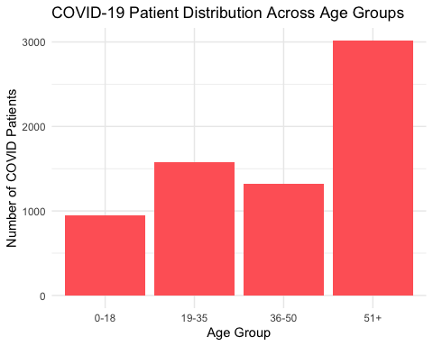
Distribution of COVID patients across Age Group
# This bar chart provides an intuitive visual comparison across age categories.It helps highlight which demographic groups are most affected by COVID-19.

Interpretation
From the plot, we see that The Age Group distribution reveals a bimodal pattern. The highest number of COVID-19 patients falls within the 51+ Age Group (approximately 3,000 cases). This is likely due to the compromised immune systems and higher prevalence of comorbidities typical in older populations, making them more susceptible to infection and severe illness.
Following closely is the 19-35 Age Group (approximately 1,700 cases). This can be attributed to their high mobility and occupational exposure, as they constitute the primary workforce, increasing their likelihood of coming into contact with high-risk environments.
Conversely, the 0-18 Age Group shows the lowest number of cases, potentially reflecting lower social contact rates or lower observed symptoms in children.

Question 2

Task explanation
This question investigates the common non-COVID conditions, primarily the symptoms and comorbidities, that experienced by patients who had confirmed or suspected COVID-19. The task involves two main parts:
Identifying and ranking the Top 5 most common non-COVID conditions (i.e., symptoms) among COVID-affected patients.
Comparing the Top 10 conditions by gender to explore whether symptom prevalence and comorbidity patterns differ between male and female patients.
Through data filtering, grouping, and visualisation, this analysis aims to highlight the most frequent co-occurring health issues among COVID patients and reveal any gender-based variations in health outcomes.

Analysis 1: Top 5 most common non-COVID conditions among COVID patients
#1. Precheck
covid_patients_id <- covid_patients_id %>% distinct(Id)
#I do this to ensure covid_patients_id exists and is unique per patient
#2.Keep ONLY conditions belonging to patients who ever had COVID, but EXCLUDE the COVID rows themselves
covid_comorbidities <- conditions %>%
semi_join(covid_patients_id, by = c("PATIENT" = "Id")) %>%
filter(!str_detect(DESCRIPTION, regex("COVID", ignore_case = TRUE)))
#I use semi_join expresses the intent clearly: filter conditions to those patients; then remove COVID strings.
#3. Clean DESCRIPTION to avoid duplicate labels due to casing/spacing
covid_comorbidities <- covid_comorbidities %>%
mutate(DESCRIPTION = DESCRIPTION %>% stringr::str_squish() %>% stringr::str_to_title()) %>%
filter(!is.na(DESCRIPTION) & DESCRIPTION != "")
#I standardise text and drop missing values to make frequency counts reliable
#4. Top 5 most common conditions
top_conditions_global <- covid_comorbidities %>%
count(DESCRIPTION, sort = TRUE) %>%
slice_head(n = 5)
#This answers “most common conditions” in terms of how often they appear in the records.
#5. Display the summary table of top 5 most common conditions other than COVID-19
kable(top_conditions_global, caption = " Top 5 most common non-COVID conditions among COVID patients", align = c("c", "c"))
Top 5 most common non-COVID conditions among COVID patients
DESCRIPTION | n
Fever (Finding) | 6088
Cough (Finding) | 4674
Loss Of Taste (Finding) | 3571
Fatigue (Finding) | 2644
Body Mass Index 30+ - Obesity (Finding) | 2608
#I use kable() to present the results in a professional, report-ready format. The table clearly present the top 5 most common conditions other than COVID-19 among COVID patients

Interpretation
From the table, we see that top 5 most common non-COVID conditions among COVID patients are “Fever”, “Cough”, “Loss of taste”, “Fatigue”, and “Body mass index 30+ - obesity” ## Analysis 2: Top 10 Non-COVID Conditions by Gender
#1. Join the COVID comorbidities dataset with patient demographics to access gender.
comorb_with_gender <- covid_comorbidities %>%
left_join(patients %>% select(Id, GENDER), by = c("PATIENT" = "Id"))
#I enrich the comorbidity dataset with gender from the patients table. This enables gender-based comparison of condition frequencies among COVID-affected patients.
#2. Count unique patients per condition per gender and select top 10
top10_by_gender <- comorb_with_gender %>%
distinct(GENDER, PATIENT, DESCRIPTION) %>%
count(GENDER, DESCRIPTION, sort = TRUE) %>%
group_by(GENDER) %>%
slice_head(n = 10) %>%
ungroup()
#I count how many unique patients of each gender have each non-COVID condition. The distinct() step ensures no duplicate patient-condition pairs are counted twice.
#3. Display a summary table showing the top 10 non-COVID conditions by gender
kable(
top10_by_gender %>% arrange(GENDER, desc(n)),
caption = "Top 10 Non-COVID Conditions by Gender (Unique Patients)",
col.names = c("Gender", "Condition", "Unique Patients"),
align = c("c", "c"))
Top 10 Non-COVID Conditions by Gender (Unique Patients)
Gender | Condition | Unique Patients
F | Fever (Finding) | 3202
F | Cough (Finding) | 2472
F | Loss Of Taste (Finding) | 1846
F | Body Mass Index 30+ - Obesity (Finding) | 1420
F | Fatigue (Finding) | 1373
F | Miscarriage In First Trimester | 1199
F | Sputum Finding (Finding) | 1190
F | Prediabetes | 1031
F | Hypertension | 882
F | Anemia (Disorder) | 757
M | Fever (Finding) | 2886
M | Cough (Finding) | 2202
M | Loss Of Taste (Finding) | 1725
M | Fatigue (Finding) | 1271
M | Body Mass Index 30+ - Obesity (Finding) | 1188
M | Sputum Finding (Finding) | 1070
M | Anemia (Disorder) | 1049
M | Prediabetes | 991
M | Hypertension | 823
M | Dyspnea (Finding) | 657
#I use kable() to present the results in a professional, report-ready format. The table clearly compares the top 10 conditions between male and female COVID patients.
#4. Create a bar chart comparing condition counts by gender
ggplot(top10_by_gender, aes(x = reorder(DESCRIPTION, n), y = n, fill = GENDER)) +
geom_bar(stat = "identity", position = "dodge") +
coord_flip() +
labs(title = "Top 10 Non-COVID Conditions by Gender",
x = "Condition",
y = "Number of Unique Patients",
fill = "Gender") +
theme_minimal() +
theme(text = element_text(size = 10))
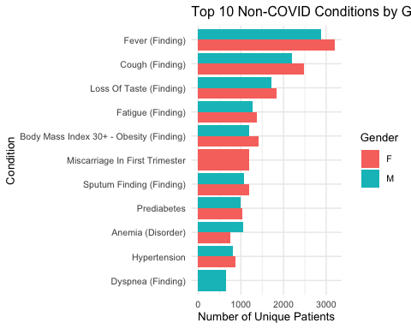
Top 10 Non-COVID Conditions by Gender (Unique Patients)
#A horizontal bar chart provides an intuitive visual comparison of the top 10 non-COVID symptoms for each gender. This helps highlight any gender-based differences in condition frequency.

Interpretation
The analysis of non-COVID conditions among COVID-affected patients reveals several key patterns. Across the overall cohort, the most frequent conditions—fever, cough, loss of taste, and fatigue—represent the classic symptomatic profile of COVID-19 infection. These findings confirm that the dataset accurately captures realistic symptom and comorbidity patterns. When comparing results by gender, both male and female patients exhibit similar top-ranked symptoms, but notable differences emerge in specific conditions. Female patients report slightly higher frequencies of fatigue, loss of taste, and reproductive-related conditions such as miscarriage in the first trimester, whereas male patients show greater prevalence of obesity, hypertension, and dyspnea. These variations may reflect biological and hormonal differences as well as behavioural and lifestyle factors influencing health outcomes.

Question 3

Task explanation
This question explores the factors that might influence the hospitalisation rate among patients who had confirmed or suspected COVID-19. The analysis focuses on comparing how selected demographic and social variables—such as age, gender, marital status, race, zip code, or county—relate to the type of health service encounters received (ambulatory, emergency, inpatient, or urgent care).
By examining patterns in encounter types across different demographic groups, this task aims to uncover whether certain groups are more likely to experience hospitalisation or require emergency care, thereby revealing potential inequalities in healthcare access or severity of illness. ## Analysis: Factors influencing hospitalisation rate
#1. Filter encounters of COVID patients only
# Keep encounters linked to patients who had confirmed or suspected COVID
covid_encounters <- encounters %>%
semi_join(covid_patients_id, by = c("PATIENT" = "Id"))
# Confirm encounter types distribution
table(covid_encounters$ENCOUNTERCLASS)
##
## ambulatory emergency inpatient outpatient urgentcare wellness
## 42371 2888 3821 25657 1708 75079
# This ensures I only analyse encounter data related to COVID-affected patients.
#2. Merge with patient demographic data
# Join patients details (e.g., age, gender, race, marital status)
reference_date <- Sys.Date()
covid_enc_master <- encounters %>%
semi_join(covid_patients_id, by = c("PATIENT" = "Id")) %>%
left_join(
covid_master_data %>% select(Id, Age_Group, GENDER, RACE, MARITAL, ZIP, COUNTY),
by = c("PATIENT" = "Id")
)
# I combine demographic and encounter details for analysis.
#3. Select Age Group and Gender as predictors to analyse
# Count how many encounters of each class occur within each age-gender group
encounter_summary <- covid_enc_master %>%
filter(ENCOUNTERCLASS %in% c("ambulatory","emergency","inpatient","urgent care")) %>%
group_by(Age_Group, GENDER, ENCOUNTERCLASS) %>%
summarise(Count = n(), .groups = "drop") %>%
group_by(Age_Group, GENDER) %>%
mutate(Proportion = Count / sum(Count))
# The dataset now shows the relative frequency of each encounter type by age and gender.
#4. Visualise results
# Create a grouped bar chart comparing encounter type proportions
ggplot(encounter_summary, aes(x = ENCOUNTERCLASS, y = Proportion, fill = GENDER)) +
geom_bar(stat = "identity", position = "dodge") +
facet_wrap(~ Age_Group) +
labs(title = "Proportion of Encounter Types by Age Group and Gender",
x = "Encounter Type",
y = "Proportion of Encounters",
fill = "Gender") +
theme_minimal()
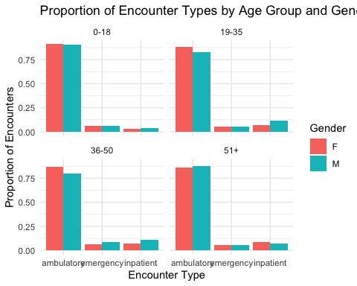
# This chart visually compares how hospitalisation and encounter types vary across demographics.

Interpretation
The results show that ambulatory encounters are the most common across all age groups, indicating most COVID-19 cases required only outpatient care. Older patients (51+) have slightly higher proportions of inpatient and emergency visits, reflecting greater illness severity. Gender differences are small, but males show marginally more inpatient encounters, while females are more likely to attend ambulatory visits. Overall, both age and gender influence hospitalisation patterns, with older adults—especially males—more likely to require hospital care. ### Question 4 ## Task explanation

##Interpretation

